B.C.M. Sen. Sec. School, Basant City, Pakhowal Road, Ludhiana.
Name Roll No. Standard III
Chapters( Learn to use MS Windows 7 , More on Paint )

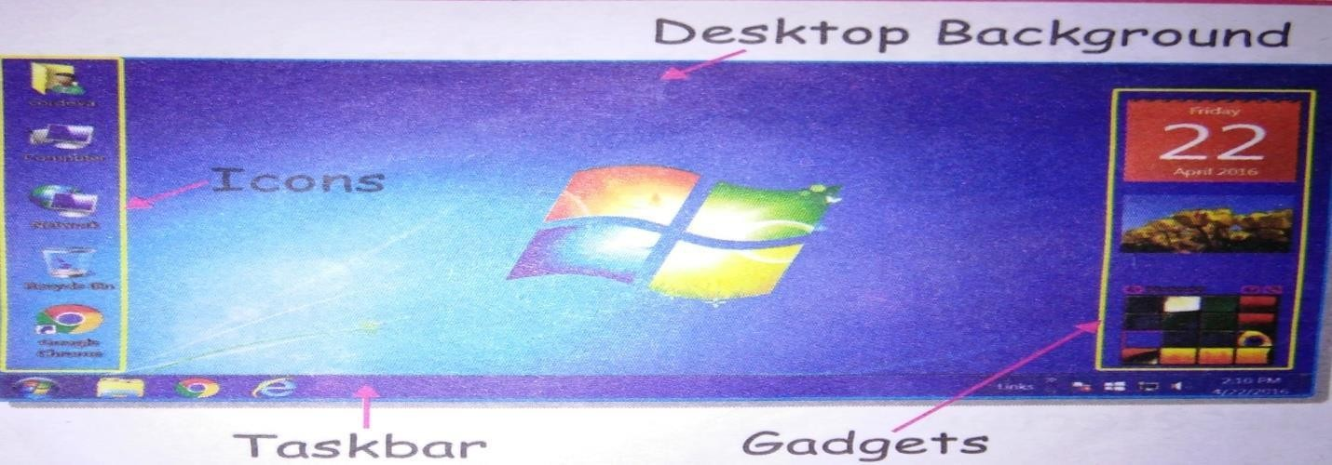
- Label the picture of Desktop .
- Draw , color and name the command used to draw each object of the picture .
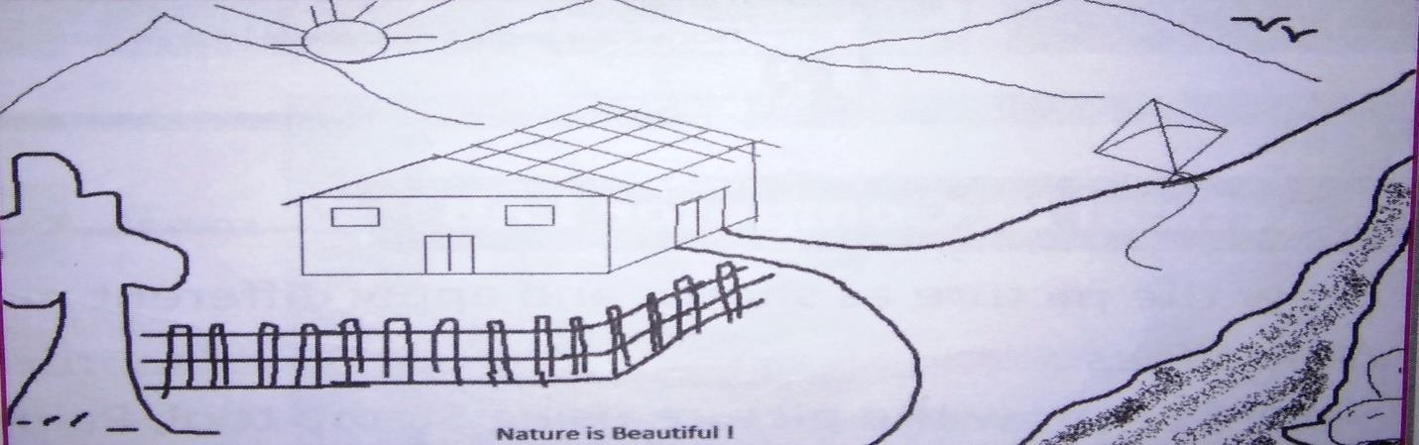

Sun | : Oval, Line | Tree | : Curve, Line
Birds | : Curve, Line | Kite | : Polygon
Hut | : Straight, Line | Stone | : Circle
- Label the different shape tools used to draw.
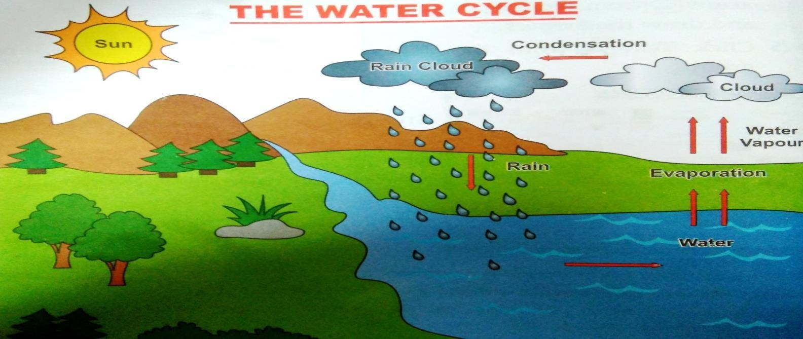

Shape tools :- | 1. Oval tool | 3. Up arrow | 5. Right arrow
 | 2. Line tool | 4. Curve tool | 6. Down arrow

- .State T for true statement and F for false statement:

- Linux is not an operating system. (F)
- Rectangular selection is used to select irregular shapes. (F)
- MS Window is the most popular application software. (F)
- Curve is used to draw curved lines. (T)
- Windows phone is developed by Microsoft corporation. (T)
- Sorting means arranging the icons in ascending or descending order on the desktop. (T)
- Delete command is used to delete the selected part of the image. (T)
- Window 7 desktop display gadgets on left side of the screen. (F)
- Ribbon contains three parts . (F)
- System tray displays the current date and time . (T)

- Give answer in one word

1. | The software that helps you to operate the computer system | Operating system
2. | The most popular system software is | MS Windows
3. | MS Windows has many flavours called | Versions
4. | Who developed the first version of Windows operating system | Bill gates
5. | The small picture that is used to open a program , files | Icon
6. | The tool which is used to draw closed plane figures | Polygon
7. | It is used to select an irregular shape area of image | Free Form Selection
8. | The tool which is used to pick color | Color Picker
9. | The latest version of Android is | Android 8.0 Oreo
10. | The shape which is used to move window in any direction | Move shape

- Fill in the blanks
Cut , taskbar , Booting , Image, Paint

  - System tray is present on the taskbar.
  - Select command is present in the Image group.
  - Booting is the process of loading the operating system into computer’s memory.
  - Paint programs is used to make drawings on the computer.
  - The Cut command is same as the copy command.

